CSE520
Samuel Marrujo
Professor Yu
Homework 4

Homework 4

In this homework, we are to finish 5 different problems. I have successfully completed this task to the best of my ability, and here are pictures of the following:

Each picture will be on a separate page as shown below.

#1:

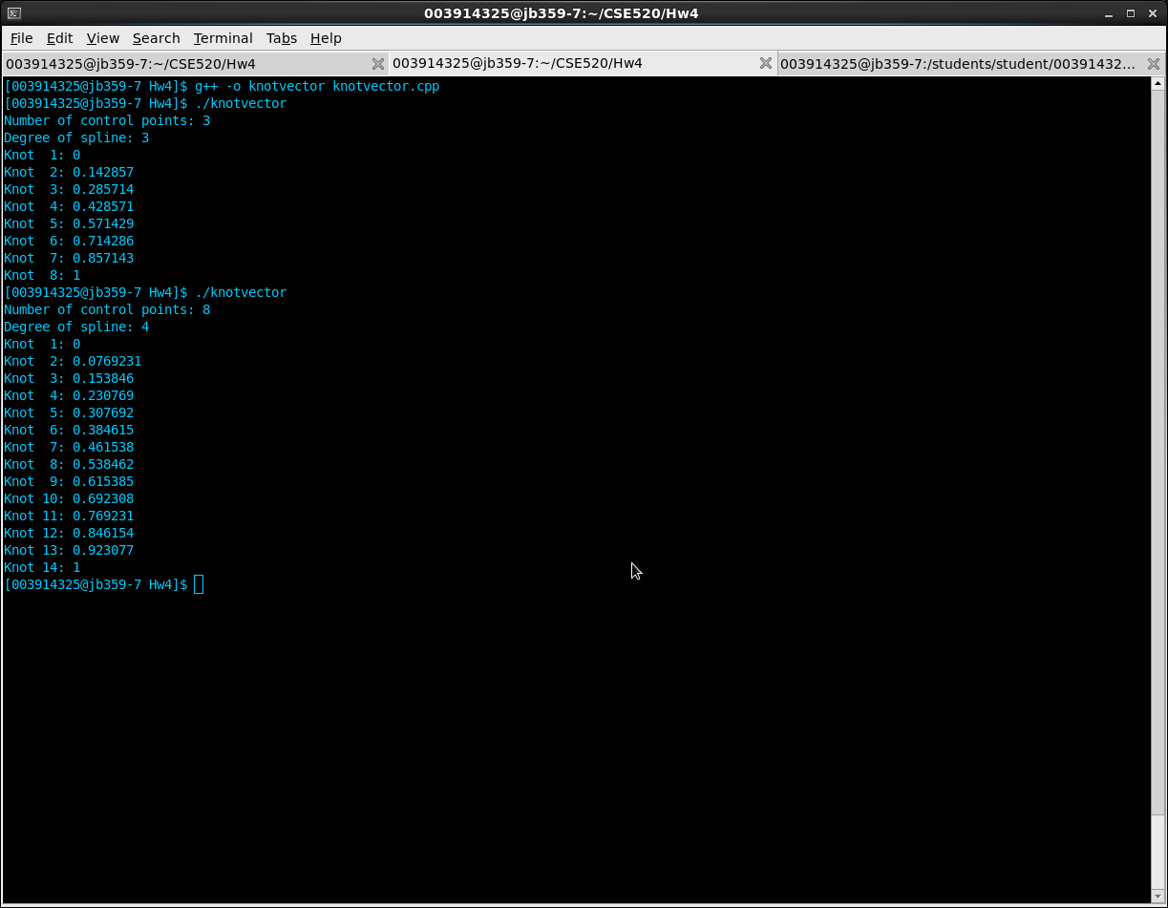
#2:
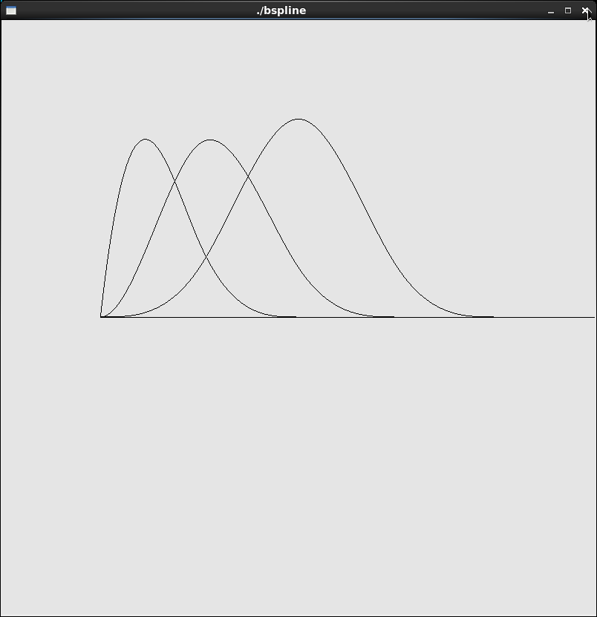
#3
This was done by hand. The solution is as follows:

[2.624 3.568 5.248]

How this was approached was done by the following method:
First, consider that we can express a cubic interpolating polynomial in a matrix form:

P = AC

Where P is the given matrix for values P(0), P(1/3), P(2/3), P(1).
C is a variable matrix and is a 3x4 matrix for each 0,..,3, by x,y,z.
A is the matrix given in the lecture notes
A = [ 1 0 0 0 ]
[ 1 1/3 (1/3)^2 (1/3)^3 ]
[ 1 2/3 (2/3)^2 (2/3)^3 ]
[ 1 1 1 1 ]

Then, from lab 14,

A inverse (Ainv)= [1 0 0 0 ]
[-5.5 9 -4.5 1 ]
[9 -22.5 18 -4.5 ]
[-4.5 13.5 -13.5 4.5 ]

Then solve for C: C = Ainv*P =

[0 0 0]
[4 9.5 8]
[-4.5 -13.5 -9]
[4.5 9 9]

Then, consider P(u) = [ x(u), y(u), z(u) ], and plug in 0.8 = u

=>
P(u) = P(0.8) = [ 1 0.8 0.64 0.512 ]*C = [2.624 3.568 5.248]
#4
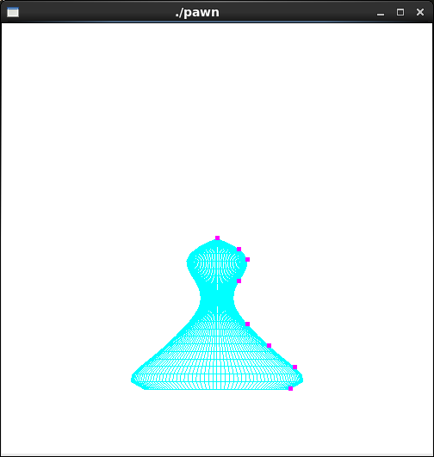
#5
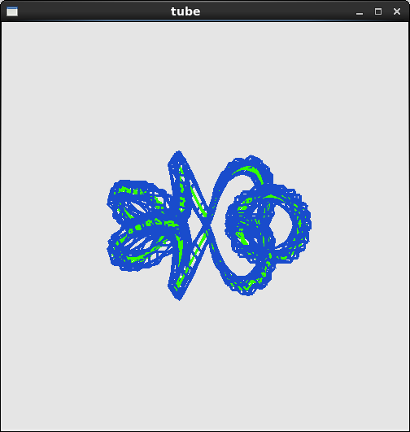
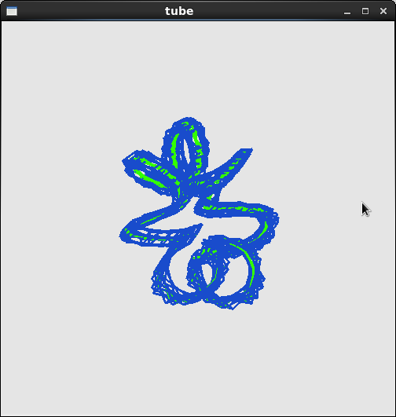
Code:
#1 is obvious. Created it's own program and used a formal way of defining points for a B-spline Curve. This way, it is used to define the control points as it should to it's exact values.
#2:
Used code similar from the lecture notes (buildknots)
//bspline.cpp

#include <GL/glut.h>
#include <iostream>

const int dx = 0.3;
const int maxL = 10;

float p[maxL][3];

using namespace std;

void build(int m, int n, float knt[]) {
if (n < m)
return; //this means there isn't enough control points, so it returns
for (int i = 0; i < n + m; ++i) {
if (i < m)
knt[i] = 0.0;
else if (i < n)
knt[i] = i - m + 1;
else
knt[i] = n - m + 1;
}
}

float bSpline(int k, int s, float u, float knt[]) {
float a;
float b;
float sum = 0.0;
if (s == 1)
return (knt[k] <= u && u <= knt[k + 1]);
a = knt[k + s - 1] - knt[k];
if (a != 0)
sum = (u - knt[k]) * bSpline(k, s - 1, u, knt) / a;
b = knt[k + s] - knt[k + 1];
if (b != 0)
sum += (knt[k + s] - u) * bSpline(k + 1, s - 1, u, knt) / b;
return sum;
}

void display(void) {
float knt[11];
build(4, 8, knt);
glClear(GL_COLOR_BUFFER_BIT | GL_DEPTH_BUFFER_BIT);
glPushMatrix();
glBegin(GL_LINE_STRIP);
for (int i = 1; i < 4; i++) {
for (float x = 0.0; x < 5.0; x += 0.01) {
float y = bSpline(i, 4, x, knt);
glVertex2f(x, y);
}
}
glEnd();
glFlush(); //renderer
}

void setWindow(double left,double right, double bottom, double top) {
glMatrixMode(GL_PROJECTION);
glLoadIdentity();
gluOrtho2D(left, right, bottom, top);
}

void init(void) {
glClearColor(0.9, 0.9, 0.9, 1.0);
glColor3f(0.0f, 0.0f, 0.0f);
glPointSize(4.0);
glMatrixMode(GL_PROJECTION);
glLoadIdentity();
gluOrtho2D(-1.0, 5.0, -1.0, 1.0);
}

void keyboard(unsigned char key, int x, int y)
{
switch (key) {
case 27:
exit(0);
break;
}
}

int main(int argc, char** argv) {
glutInit(&argc, argv);
glutInitDisplayMode(GLUT_SINGLE | GLUT_RGB);
glutInitWindowSize(800, 800); //sets the window size on screen
glutInitWindowPosition(100, 150); //sets the window position on screen
glutCreateWindow(argv[0]);
init();
glutDisplayFunc(display); //references the display function
glutKeyboardFunc(keyboard); //used to exit the program with 'ESC'
glutMainLoop();
return 0;
}

#3
See above
#4

Used sweep1.cpp to begin creating the pawn.

/* sweep1.cpp
* Construct surfaces of revolution using wireframe but have not considered lighting.
* Surface is generated by revolving a curve around x-axis.
* A curve f(x) is generated by polynomial interpolation from some control points
* or by some interested functions.
*
* @Author: T.L. Yu, Fall 2008
*/
#include <GL/glut.h>
#include <stdlib.h>
#include <stdio.h>
#include <math.h>
#include <stdlib.h>

using namespace std;

const double PI = 3.14159265389;
int Npoints = 8;
int anglex= 0, angley = 0, anglez = 0; //rotation angles
int window;

//control points
GLfloat ctrlpoints[8][3] = {
{0.0, 0.0, 0.0}, {0.25, 0.5, 0.0}, {0.5, 0.7, 0.0}, { 1.0, 0.5, 0.0},
{2.0, 0.7, 0.0}, {2.5, 1.2, 0.0}, {3.0, 1.8, 0.0}, {3.5, 1.7, 0.0}
};

void init(void) {
glClearColor(1.0, 1.0, 1.0, 1.0);
glPolygonMode( GL_FRONT, GL_LINE ) ;
glPolygonMode( GL_BACK, GL_LINE ) ;
glShadeModel(GL_FLAT);
}

//polynomial interpretation for N points
float polyint ( float points[][3], float x, int N )
{
float y;

float num = 1.0, den = 1.0;
float sum = 0.0;

for ( int i = 0; i < N; ++i ) {
num = den = 1.0;
for ( int j = 0; j < N; ++j ) {
if ( j == i ) continue;

num = num * ( x - points[j][0] ); //x - xj
}
for ( int j = 0; j < N; ++j ) {
if ( j == i ) continue;
den = den * ( points[i][0] - points[j][0] ); //xi - xj
}
sum += num / den * points[i][1];
}
y = sum;

return y;
}

float aLine ( float x )
{
return x + 2.5;
}

void display(void)
{
int i, j;
float x, y, z, r; //current coordinates
float x1, y1, z1, r1; //next coordinates
float theta;

glClear(GL_COLOR_BUFFER_BIT);
glColor3f(0.0, 1.0, 1.0);
const float startx = 0.0, endx = 3.5;
const int nx = 20; //number of slices along x-direction
const int ntheta = 128; //number of angular slices
const float dx = (endx - startx) / nx; //x step size
const float dtheta = 2*PI / ntheta; //angular step size

x = startx;
//r = aLine ( x );
r = polyint( ctrlpoints, x, Npoints);
glPushMatrix();
glRotatef( anglex, 1.0, 0.0, 0.0); //rotate the object about x-axis
glRotatef( angley, 0.0, 1.0, 0.0); //rotate about y-axis
glRotatef( anglez, 0.0, 0.0, 1.0); //rotate about z-axis

for ( i = 0; i < nx; ++i ) { //step through x
theta = 0;
x1 = x + dx; //next x
//r1 = aLine ( x1 ); //next f(x)
r1 = polyint( ctrlpoints, x1, Npoints); //next f(x)
//draw the surface composed of quadrilaterals by sweeping theta
glBegin( GL_QUAD_STRIP );
for ( j = 0; j <= ntheta; ++j ) {
theta += dtheta;
double cosa = cos( theta );
double sina = sin ( theta );
y = r * cosa; y1 = r1 * cosa; //current and next y
z = r * sina; z1 = r1 * sina; //current and next z

//edge from point at x to point at next x
glVertex3f (x, y, z);
glVertex3f (x1, y1, z1);

//forms quad with next pair of points with incremented theta value
}
glEnd();
x = x1;
r = r1;
} //for i

glPointSize(5.0);
glColor3f(1.0, 0.0, 1.0);
glBegin(GL_POINTS);
for (i = 0; i < Npoints; i++)
glVertex3fv(&ctrlpoints[i][0]);
glEnd();
glPopMatrix();
glFlush();
}

#5
This code started off from the helix-tube1.cpp code in the extrude folder of meshes in lab4.

This was suggested from the lecture notes to look in here.

int angle_x= 0, angle_y = 0, angle_z = 0;
int window;

void getC(float C[4], float t, float b) {
C[0] = (1 + b * cos(7*t))*cos(t);
C[1] = (1 + b * cos(7*t))*sin(t);
C[2] = b*sin(7*t);
C[3] = 1;
}

void setM( LinearMapR4 &Mat, float t, float b ) {

float c = 1.0 / sqrt(1 + b*b);
Mat.SetColumn1(-cos(t)*(1 -b * cos ( 7*t )), -sin(t)*(-b * cos(7*t)), 0, 0 );
Mat.SetColumn2(c*b*sin(t)*(1 + b*cos(7*t)), -c*b*cos(t)*(1 - b*cos(7*t)), c, 0 );
Mat.SetColumn3(-c*sin(t)*(1 + b*cos(7*t)), c*cos(t)*( 1 + b*cos(7*t)), b*c, 0);
Mat.SetColumn4(cos(t)*(1 + b*cos(7*t)), sin(t)*(1 + b*cos(7*t)), b*sin(7*t), 1);

}

class Cfloat3 {
public:
float p3[3];
};

const float b = 0.5;
double H = 6.0;
LinearMapR4 Mat;
const int N = 4;

void display(void) {
glClear(GL_COLOR_BUFFER_BIT | GL_DEPTH_BUFFER_BIT);

vector<Cfloat3>vp0(N), vp1(N);
VectorR4 p_1;
VectorR4 points[4];

points[0] = VectorR4 (-0.1, -0.1, 0, 1 );
points[1] = VectorR4 ( 0.1, -0.1, 0, 1 );
points[2] = VectorR4 ( 0.1, 0.1, 0, 1 );
points[3] = VectorR4 ( -0.1, 0.1, 0, 1 );
glColor3f ( 0.2, 1.0, 0 );
glPushMatrix();
glRotatef(angle_x, 1.0, 0.0, 0.0);
glRotatef(angle_y, 0.0, 1.0, 0.0);
glRotatef(angle_z, 0.0, 0.0, 1.0);

float C[4];
glLineWidth(3);
glPolygonMode(GL_FRONT, GL_LINE);
glPolygonMode(GL_BACK, GL_LINE);

glBegin(GL_LINE_STRIP);
for(float t = 0; t <= 26; t += 0.2) {
getC(C, t, b);
glVertex4fv(C);
}
glColor3f(0.1, 0.3, 0.8);
glEnd();
float p3[3];

setM(Mat, 0, b);

for (int i = 0; i < 4; ++i) {
p_1 = Mat * points[i];
p_1.Dump(vp0[i].p3);
}
glBegin(GL_QUADS);

for (float t = 0.2; t <= 26; t += 0.2) {
setM (Mat, t, b);
for (int i = 0; i < N; ++i) {
p_1 = Mat * points[i];

p_1.Dump(vp1[i].p3);
}
for (int i = 0; i < N; ++i) {
int j = (i+1) % N;
glVertex3fv(vp0[i].p3);
glVertex3fv(vp0[j].p3);
glVertex3fv(vp1[j].p3);
glVertex3fv(vp1[i].p3);
}
copy(vp1.begin(), vp1.end(), vp0.begin());
}
glEnd();
glPopMatrix();
glFlush();
}

void keyboard ( unsigned char key, int x, int y ) {
switch (key) {
case 27:
glutDestroyWindow(window);
exit (0);
case 'x':
angle_x = (angle_x + 3) % 360;
break;
case 'X':
angle_x = (angle_x - 3) % 360;
break;
case 'y':
angle_y = (angle_y + 3) % 360;
break;
case 'Y':
angle_y = (angle_y - 3) % 360;
break;
case 'z':
angle_z = (angle_z + 3) % 360;
break;
case 'Z':
angle_z = (angle_z - 3) % 360;
break;
case 'r':
case 'R':
angle_z = angle_y = angle_x = 0; //resets the angles
break;
}
glutPostRedisplay();
}

int main( int argc, char *argv[] ) {
glutInit( &argc, argv );
glutInitDisplayMode(GLUT_SINGLE | GLUT_RGB | GLUT_DEPTH );
glutInitWindowSize( 500, 500 );
glutInitWindowPosition( 100, 100 );
window = glutCreateWindow("tube");
glutDisplayFunc(display);
glutKeyboardFunc( keyboard );
glClearColor( 0.9f, 0.9f, 0.9f, 0.0f ); //light gray background
glViewport ( 0, 0, 500, 500 );
init ();
glutMainLoop();
return 0;
}

